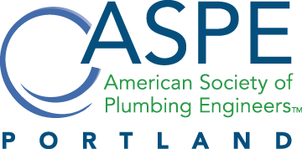
Plumbing Engineers, Designers, Contractors and Affiliates

Date: November 13th 2019 |  | $ 25.00 per Person  No Cost for PSU Students
Time: 4 to 6 PM  Location: PAE  522 SW 5th Ave, Suite 1500  Portland, OR 97204 |  | Web Registration @ aspepdx.com  E-Registration @ portlandaspe@gmail.com
"Digital Mixing Valves vs. Stations vs. Solutions"
Speaker: Dennis DeHaan (Acorn Controls)

Join us for this month’s presentation about Digital Mixing valve solutions.

Social hour with refreshments beginning 4pm and presentation at 5pm.

ASPE PORTLAND
Technical Meeting

ANNOUNCEMENTS:

Upcoming Women of ASPE (WOA) event on November 14th, 2019.

Please email portlandaspe@gmail.com if you have any comments.

ASPE Portland Chapter 2019-2020 Board Members – Contact Us!
Chapter President: Dan Somlea dan.somlea@pae-engineers.com
VP Technical: Charles Norris charles.norris@pae-engineers.com
VP Legislative: Todd Shoote todd.shoote@pae-engineers.com
VP Membership: Eric Halberg eric@qsireps.com
Treasurer: Matt Burleigh matt.burleigh@mechagents.com
Admin Secretary: Andrew Flanagan ajflanagan@gmail.com
Corresponding Secretary: Joshua Reiser joshsreiser@gmail.com
Affiliate Liaison: Tom Puhl tomp@braleygray.com
Newsletter Editor: Phil Roach proach@mazzetti.com
Webmaster: Chris Peddie chrisp@braleygray.com
AYP Liaison: Travis Lewis travis.lewis@pae-engineers.com
WOA Liaison: Victoria Haynes Victoria.haynes@pae-engineers.com

